March 10, 2014

Basket App Revision

Newsfeed tab

* The compose a status or review button should be in the top right (similar position to the search button) for all pages other than the profile tab(replaced with the settings button)



* User’s Name (i.e. Romulan Commander) should be clickable, and go to their profile page
  + When somebody reviews somebody else, or mentions them in a status, their name should also be clickable and go to their respectable profile page
* Reviews should show the physical rating (1-5 stars) on this newsfeed page
* When multiple photos are displayed in an expanded status, clicking the photos doesn’t expand the photos into full screen mode.
  + Full screen photo viewing from the above action should allow the user to swipe between the photos in the status
* If user has posted more than 4 photos in a status, show the (+) to indicate additional photos
* For a status with photos, depending on how many are posted with a status they should be centered. It appears correct but they are all four photo status’...just wanted to make sure if a user posted only one or two, they would still be centered
* There should be a time stamp for the reviews or status’. A status should look similar to twitter

Here is an example of a twitter status, we like the format how the status (status and review for us) is below the name and username. Also, notice the time stamp on the right side.



* Could we possibly see what it would look like when somebody else comments on a review or status? This would be shown when the review/status has been expanded from the newsfeed.

Profile tab

* The settings button should be on the top right of the screen, takes the place of the compose a status button.
* The status and review section should have a view more button at the button of the three most recent status or reviews (similar to twitter when you are viewing a users profile). Once the “View more” is clicked, it will go to a page of only status’ or a page only of reviews)

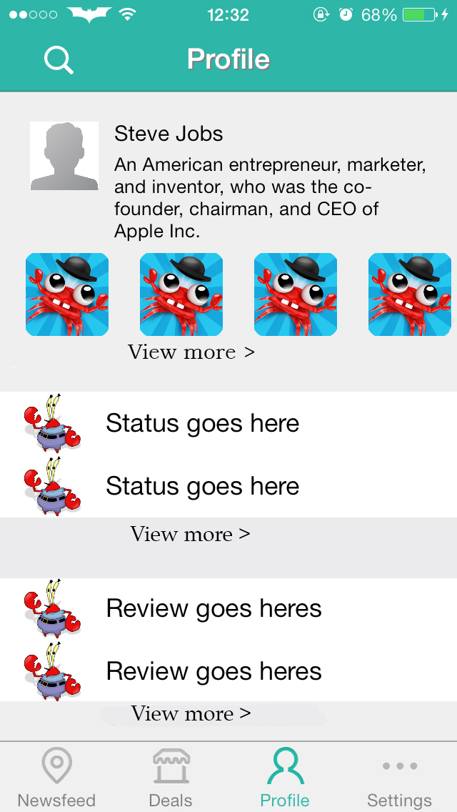

* Currently scrolling down brings the “status goes here” behind the crab pictures, it doesn’t catch or stay where it should when going down on the screen
* Profile picture should be clickable to expand into full screen
* Search button is inactive
* Between bio, picture stream, statuses, and reviews, a horizontal line should separate each section. (similar to the line separation on the newsfeed)
* The format of the status and reviews should be the same as they appear on the newsfeed (see twitter example)
* Photo library from profile would include photos from status’ and reviews
* Like how the photo stream can scroll sideways but can we include the view more button to bring you to a page of the photos (similar to what would happen if you click “view more” status)

“Daniel- Great job, it works great thus far and I love the star trek and SpongeBob touches! Keep up the awesome work.” -Max



